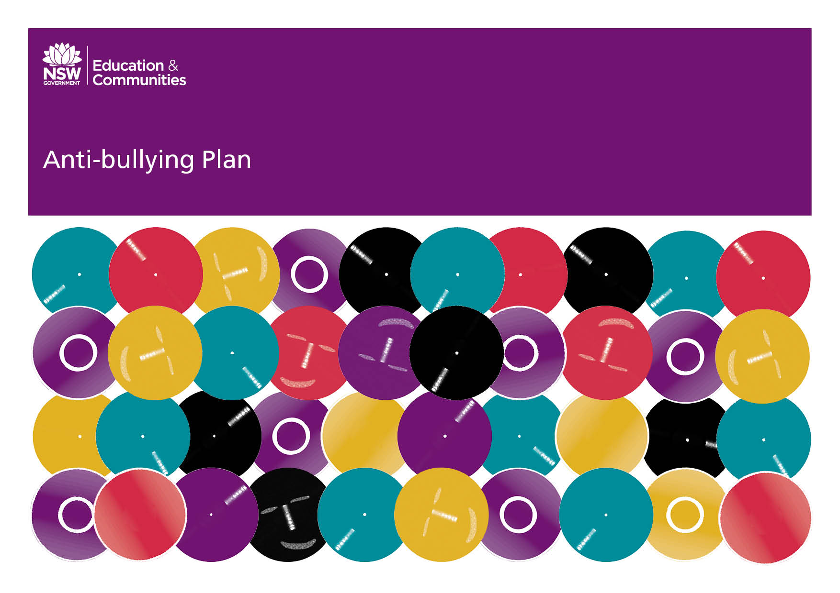
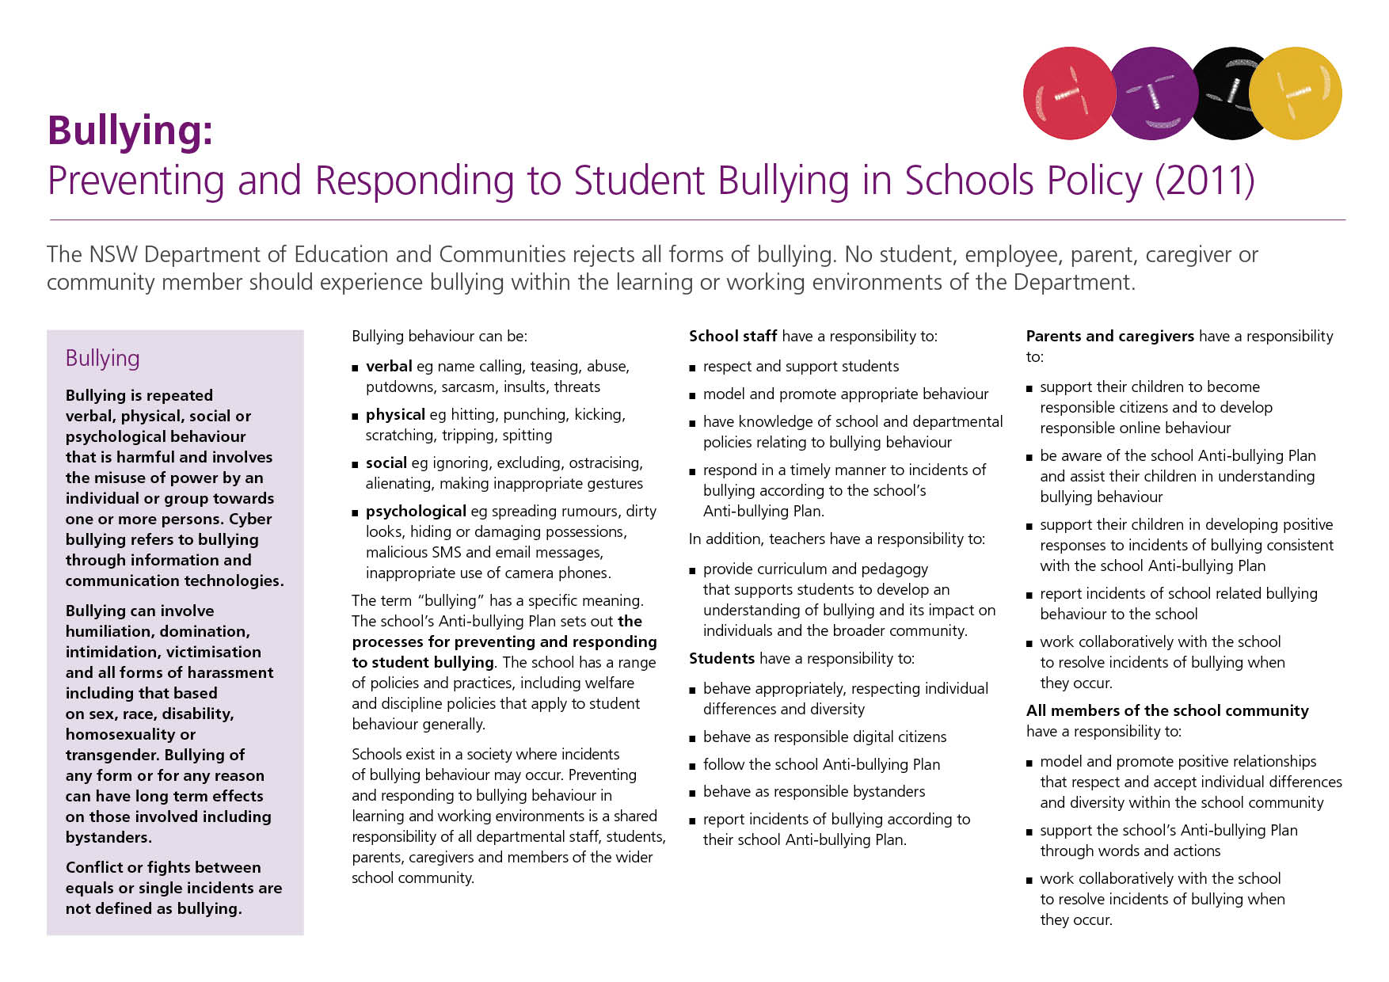
Our School Anti-Bullying Plan
Mullaway Primary School Updated February 2018

Our School Anti-Bullying Plan
This plan outlines the processes for preventing and responding to student bullying in our school and reflects the Bullying: Preventing and Responding to Student Bullying in Schools Policy of the New South Wales Department of Education and Communities.
In 2010, all students, parents and teachers were given the opportunity to participate in an online survey relating to bullying and racism within our school.
Further consultation with representation from all elements of school community, including the P&C executive, SRC and the Learning Support Team committee, was undertaken in developing this policy.

Statement of Purpose
Mullaway Primary School is committed to providing a safe environment and addressing bullying issues when they occur in accordance to school and Department of Education and Communities’ policy.
Protection
Bullying is repeated verbal, physical, social or psychological behaviour that is harmful and involves the misuse of power by an individual or group towards one or more persons. Cyber bullying refers to bullying through information and communication technologies.
All students, parents, caregivers and teachers share the responsibility in preventing and responding to bullying behaviour.

The Mullaway Code of Conduct’s rights include:
- I have the right to feel happy, safe and secure in our school environment, and;
- I have the right to be respected and treated fairly
The responsibilities that come with these rights include:
- It is my responsibility to help and care for others,
- It is my responsibility to act in a non-violent and peaceful way, and;
- It is my responsibility to respect myself, others and our differences
Bullying issues will be dealt with in neutral, fair and unbiased way. Allegations and incidents will be investigated in a timely manner and decisions will be based upon the information and evidence gathered through investigation.
Consequences will be consistent with our school discipline policy and in persistent or serious incidents, with the DEC’s suspension procedures at the discretion of the principal.
Prevention
The strategies and programs Mullaway Primary School will implement for bullying prevention include; The Code of Conduct, Peer Support, Kelso’s Resilience Wheel, ‘Bounce Back’ strategies and Kindy Buddies.
Anti-Bullying information will be distributed to the school community via the newsletter, Facebook and school website.
Annual online anti-bullying surveys(TTFM) will be conducted to monitor and respond to bullying trends within the school.
The Cyber Safety Resource package created by NBCoS will be embedded in regular class PD/H/PE sessions.
Mullaway Primary School uses Sentral Student Welfare reporting software to monitor individual student behaviour patterns.
Students are not permitted to bring their own personal digital devices.
Early Intervention
The early intervention strategies and programs Mullaway Primary School will implement for students who are identified as being at risk of developing long-term difficulties with social relationships and those students who are identified at or after enrolment as having previously experienced bullying or engaged in bullying behaviour will be implemented in consultation with the school’s Learning Support team committee.
Response
Mullaway Primary School will regularly communicate with and provide information to empower the whole school community to recognise and respond appropriately to bullying, harassment and victimisation and behave as responsible bystanders via newsletters, the school website and information sessions.
Procedures for reporting incidents of bullying at your school will include informing the child’s classroom teacher or the teacher on playground duty. The implementation of Sentral Student Welfare reporting software will monitor the frequency for these reports and individual behaviour patterns.
All persistent and serious incidents are to be reported to the Principal and Police.
All incidents of bullying are to be investigated in a neutral, fair and unbiased way. Incidents are to be investigated in a timely manner and decisions will be based on information and evidence gathered through the investigative process.
Strategies and programs Mullaway Primary School will implement to support any student who has been affected by, engaged in or witnessed bullying behavior will be in consultation with the Learning Support Team committee.
For persistent and serious bullying incidents, the principal is responsible for providing regular updates, within the bounds of privacy legislation, to parents and caregivers about the management of bullying incidents that have been reported to the school.
The school will report incidents involving assaults, threats, intimidation or harassment to the School Safety and Response on 1300 363 778 and/or the police on 000.
Where applicable the Child Wellbeing Unit decision trees will be used with regard to contacting Community Services.
Parents have the right to appeal decisions and can contact the school on 6654 0377 to receive information about the Complaints Handling Policy.
Incidents of bullying which merit Level 4, a formal caution or suspension are recorded in the student’s record and can be used to monitor patterns of bullying behaviours.
The school will promote and publicise this Anti-bullying Plan via the newsletter and will be available on the school website.
An annual online anti-bullying survey will be available to monitor and evaluate the effectiveness of the Anti-bullying Plan.
The effectiveness of the Anti-bullying Plan will be reported annually via the Annual School Report.
Mullaway Primary School will review this Anti-bullying Plan with the school community in 2016.
Principal’s Comment
This plan has been developed in consultation with the following representatives of the Mullaway School Community and has my full support.
David King (Relieving Principal), Zoe Hills (Relieving Assistant Principal), Leanne Bartlett (School Administration Manager), Julie Marshall (P&C President) and Quinn Watson/Mikaila Watson (School Captains).
School Contact Information
Mullaway Primary School
15 Whitton Place Mullaway 2450
Ph: 6654 0377 Fax: 6654 2751
Email: mullaway-p.school@det.nsw.edu.au
Web : www.mullaway-p.schools.nse.edu.au

